DSA LAB 1

1.1 write a program in python to add, subtract, multiply and divide 5 numbers.

Source code
num1 = input("Enter 1st number: ")
num2 = input("Enter 2nd number: ")
num3 = input("Enter 3rd number: ")
num4 = input("Enter 4th number: ")
num5 = input("Enter 5th number: ")

num1 = float(num1)
num2 = float(num2)
num3 = float(num3)
num4 = float(num4)
num5 = float(num5)

sum1 = num1+num2+num3+num4+num5
product = num1*num2*num3*num4*num5
divide = num1/num2/num3/num4/num5
difference = num1-num2-num3-num4-num5

print("Sum of the numbers is: ", sum1)
print("Product of the numbers is: ", product)
print("Quotient of the numbers is: ", divide)
print("Difference of the numbers is: ", difference)

Output
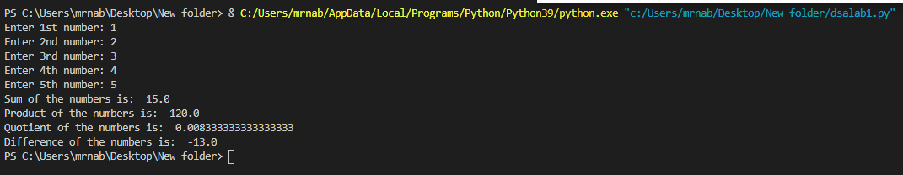

1.2 write a program in python to display your data in Nadra using editor window procedure.

Source code
print(“=====Nadra Form for New ID Card=====”)
num1 = input("Enter your Name: ")
num7 = input("Enter your Father's name: ")
num2 = input("Enter your Birthday: ")
num3 = input("Enter your Age: ")
num4 = input("Enter your Gender: ")
num5 = input("Enter your Nationality: ")
num6 = input("Enter your Address: ")

print("Name : ", num1)
print("Father's name: ", num7)
print("Birthday : ", num2)
print("Age : ", num3)
print("Gender : ", num4)
print("Nationality : ", num5)
print("Address : ", num6)

Output
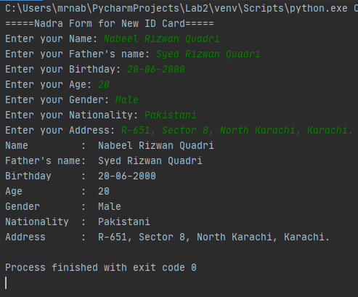

1.3 write a program in python to display a table of 5.

Source code

a = input("Enter the table number: ")
a = int(a)
for x in range(13):
print(a, " * ", x, " = ", x*a)

Output
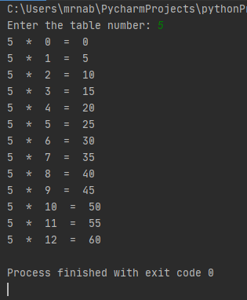

1.4. Write a Python program to reverse the order of the items in the array

Source code
from array import *
array_num = array('i', [1, 3, 5, 3, 7, 1, 9, 3])
print("Original array: "+str(array_num))
array_num.reverse()
print("Reverse the order of the items:")
print(str(array_num))

Output

